**PRICE:** $17.96

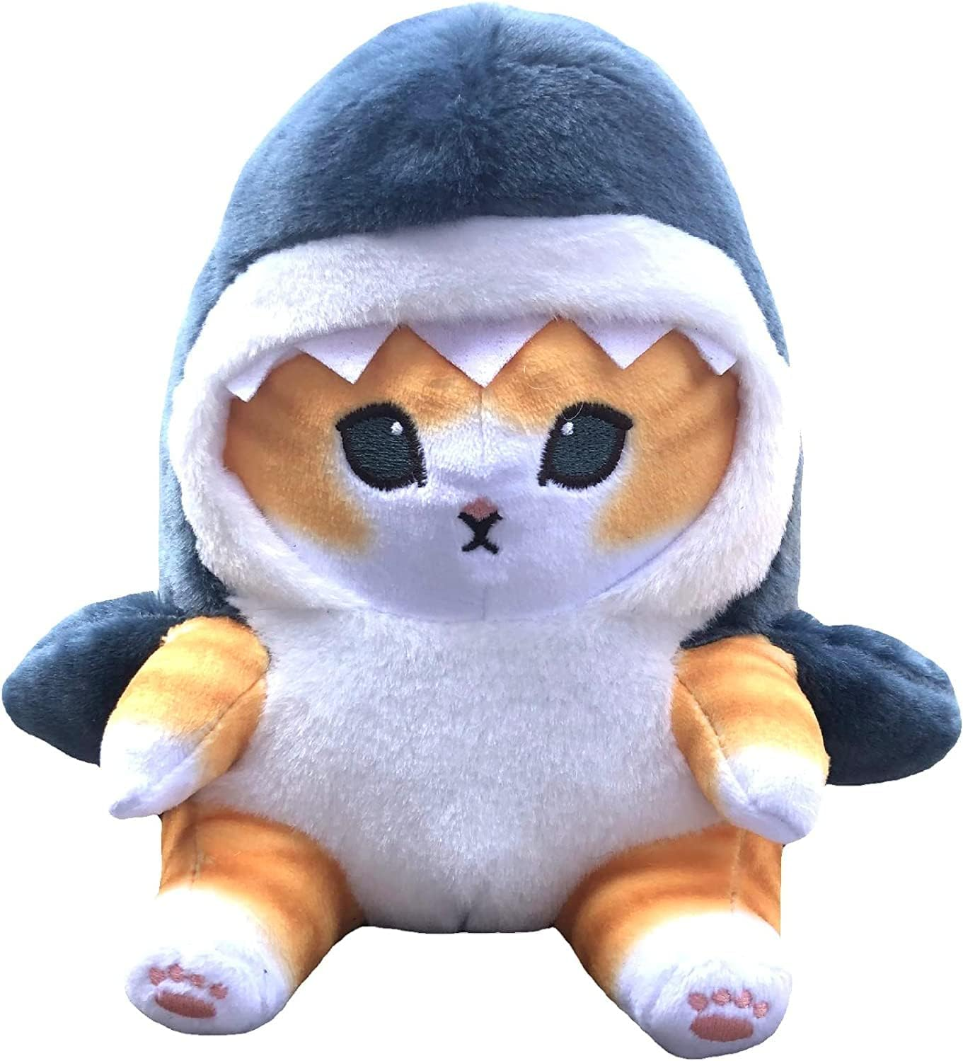

**ID:** S-01

**Size:** 8.1 inch

**BRAND:** CƯỜNG CON GIFT

* 【Material】Our plush toys are made of children's safe materials, high-quality PP cotton filling, from outer fabric to inner filling, 100% handmade, finely stitched for softness and comfort, with meticulous internal wiring technology , Fill evenly, not deformed, not afraid of extrusion.
* 【Easy to Clean】: If you accidentally stain the plush toy pillow, please use a small amount of soapy water to remove the stain, then let it dry naturally. Machine washable, but hand washing is recommended. Machine washing ruins the softness of the pillow!
* 【Design inspiration】--Inspiration comes from cartoon animation. Their cute appearance looks realistic and interesting, and people of all ages will love them.
* 【Home Decoration】Except as a great gift, this sharkcat plush doll is also suitable for home decoration, you can put it on the sofa,car,patio and car; or as party decorations for Christmas parties, New Year parties, shopping mall activities, family dinners etc.